EX NO:6
DATE:

Experiment Title:
Modeling of Swiggy Online Food Ordering System using UML

Aim:
To design and understand the working of the Swiggy Online Food Ordering System using UML Class Diagram and Sequence Diagram.

Software Used:
• UML Drawing Software (SmartDraw)

Introduction:
UML (Unified Modeling Language) is used to design and represent software systems visually. The Swiggy Online Food Ordering System allows customers to order food from restaurants using a mobile or web application. It includes features such as menu display, online payment, order confirmation, tracking, and invoice generation. UML diagrams help in understanding the system structure and behavior before implementation.

System Description:
The Swiggy system is divided into four main components: Customer, Swiggy Interface, Order Server, and Swiggy Database. Each component plays a specific role in order processing.

Class Diagram Description:

Class: Customer
- Attributes:
- Name : String
- PhoneNumber : String
- Address : String

Class: SwiggyInterface
- Methods:
- DisplayMenu()
- TrackOrder()
- ShowOffers()
- ProcessPayment()
- PrintInvoice()

Class: OrderServer
- Methods:
- FetchRestaurantDetails()
- ValidatePayment()
- AssignDeliveryPartner()
- CalculateETA()

Class: SwiggyDatabase
- Methods:
- VerifyUser()
- CheckInventory()
- LogOrderHistory()
- UpdateBalance()

Relationship Description:
Customer → SwiggyInterface (Uses)
SwiggyInterface → OrderServer (Sends Request)
OrderServer → SwiggyDatabase (Accesses Data)

UML Diagram
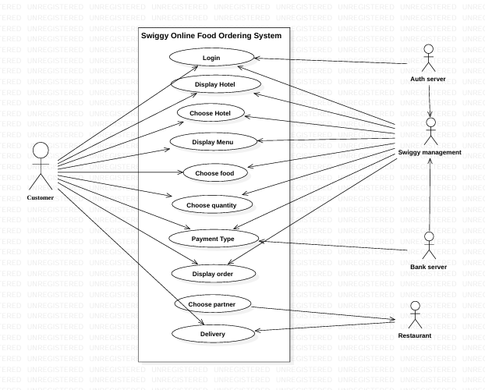

- Customer opens the application
- Selects restaurant and food items
- Interface requests menu from Order Server
- Server collects data from Database
- Menu is shown to Customer
- Customer confirms order
- Payment request is sent
- Database verifies account
- Payment is approved
- Order is stored
- Receipt is generated
- Order tracking starts

System Advantages:
- Easy food ordering
- Secure payment system
- Fast processing
- Real-time tracking
- Digital invoice facility

Applications:
- Online food delivery platforms
- Restaurant management systems
- E-commerce systems
- Mobile ordering applications

Conclusion:
The UML diagrams provide a clear understanding of the system structure and workflow. The Class Diagram explains system structure, and the Sequence Diagram explains the interaction between components. This modeling helps in designing an efficient and secure food ordering system.

Result:
The Swiggy Online Food Ordering System was successfully modeled using UML Class and Sequence Diagrams. All system components and their interactions were clearly identified and explained.

